1.
SELECT COUNT(CustomerName)
FROM Customers
WHERE Country='Germany';

2.
SELECT COUNT(ContactName)
FROM Customers
WHERE ContactName LIKE '%e';

3.
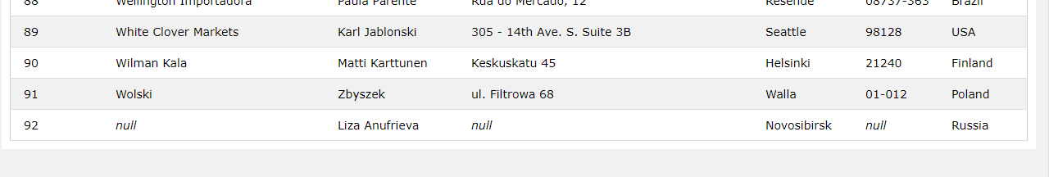
INSERT INTO Customers (ContactName, City, Country)
VALUES ('Liza Anufrieva', 'Novosibirsk', 'Russia');

4.
UPDATE Customers
SET ContactName = 'Elizaveta Anufrieva'
WHERE CustomerID = 92;
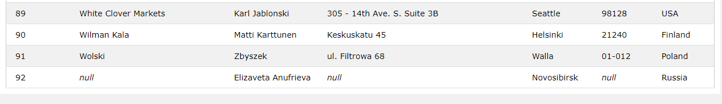

5.
DELETE FROM Customers
WHERE City='Nantes';

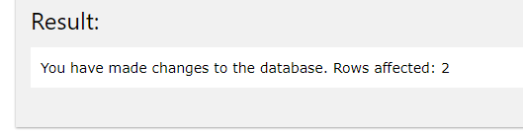

6.
SELECT Orders.OrderID
FROM Orders
INNER JOIN Employees ON Orders.EmployeeID = Employees.EmployeeID
WHERE Employees.FirstName='Steven'

